

**Capstone Project: UK Train Rides**

### 1. Team Name: Elite Team

### 2. Selected Project: Project Idea 6: (Outstanding): UK Train Rides.

**3. Team Leader: Ahmed Hussein Ali Mustafa**

**The group:**

| **No.** | **Full Name in English** | **Full Name in Arabic** | **Student ID** | **Education Background** | **Governorate** |
| --- | --- | --- | --- | --- | --- |
| **1** | **Ahmed Hussein Ali Mustafa** | **أحمد حسين علي مصطفى** | **21090350** | **MBA + Bachelor of commerce in accounting** | **Suez** |
| **2** | **Fatma Alzahraa Galal Abd-elsalam Soliman** | **فاطمه الزهراء جلال عبد السلام** | **21090461** | **Bachelor of Pharmacy** | **New Valley** |
| **3** | **Heba Tallah Talaat Ezzat Ibrahim** | **هبه الله طلعت عزت ابراهيم** | **21077992** | **Master's degree in science + bachelor’s degree in science** | **Suez** |
| **4** | **Kareman Mohamed Mahmoud Awad** | **كاريمان محمد محمود عوض** | **21090780** | **Bachelor of engineering** | **Gharbia** |

**Tools Selected**

**You need to select three different tools at least: Excel, Power BI, Tableau, Python, SQL**

**Answer:** Excel,Tableau and SQL.

* Data cleaning and transformation
* Data modeling, analysis
* Data visualization
* Dashboard creation

**Business Questions:**

1. **Operational Efficiency:**
   * What is the overall on-time performance of train journeys?
   * How many journeys were delayed, and what were the reasons? And determine the effect on refund requests ?
   * How many journeys were cancelled? What is its percentage ?
   * What are the peak travel times and most popular departure stations?
   * What is the relationship between weather conditions and train punctuality? Or What is the effect of weather conditions on all train journeys?
2. **Financial Analysis:**
   * What is the total revenue generated from ticket sales?
   * Which ticket class (Standard, First Class) generates the most revenue?
   * What are the most common train routes based on ticket sales?
   * How do different payment methods correlate with ticket purchases?
   * What are the peak hours for train travel, and how do they impact revenue?
3. **Customer Behavior:**
   * What are the most crowded departure and arrival stations?
   * Which railway lines have the highest passenger demand based on ticket sales?
   * What is the distribution of ticket types (Advance, Off-Peak, Anytime) purchased?
   * How does the purchase time affect ticket prices?
4. **Demographic Insights:**
   * What is the distribution of rail card types (Adult, Senior, Disabled, etc.) used?
   * Which payment methods are most commonly used?
5. **Route Analysis:**
   * Which routes are the most frequently traveled?
   * What is the average journey duration for different routes?
   * Are there any routes with consistently high delays?

**Mockups**

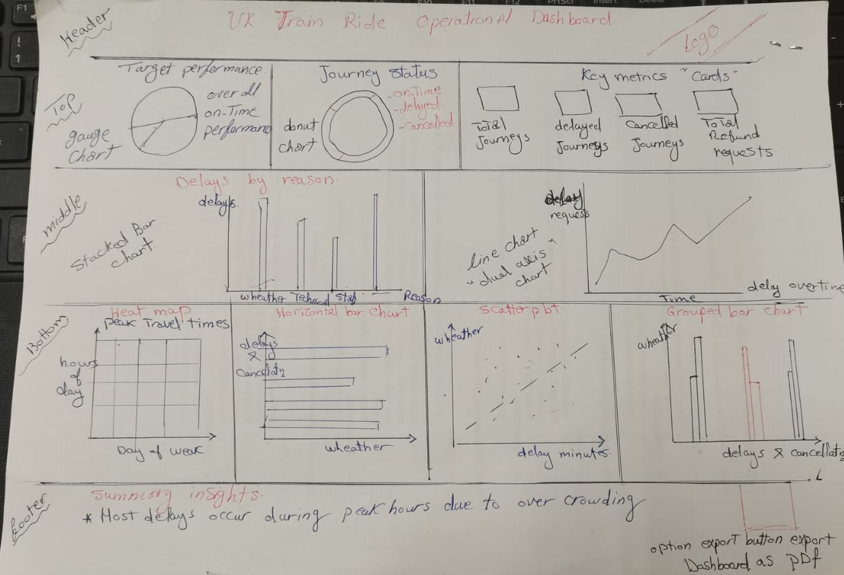

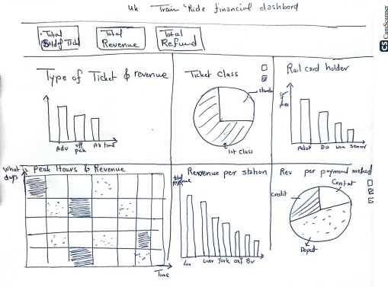

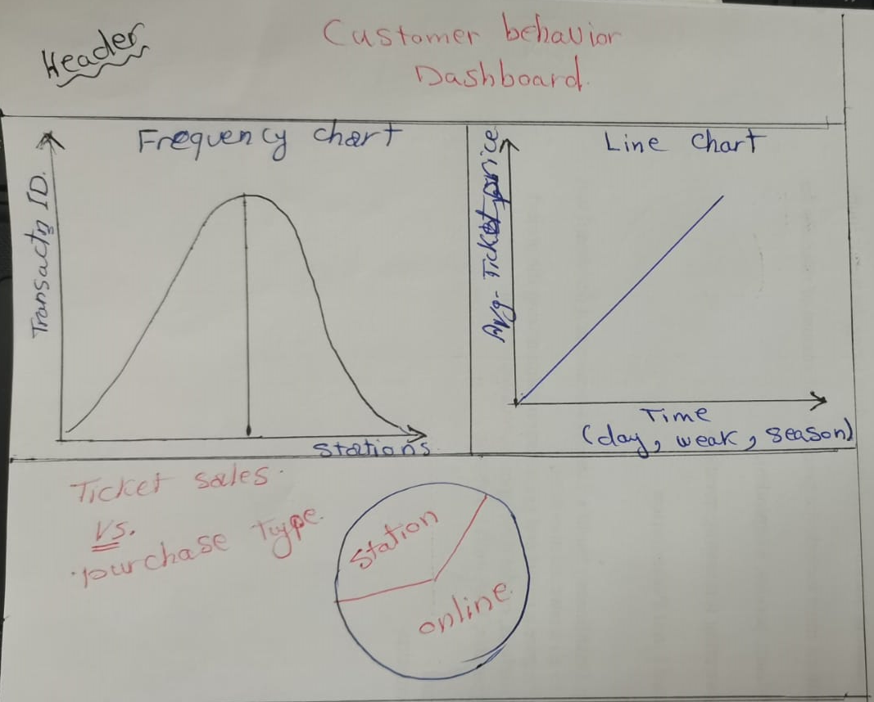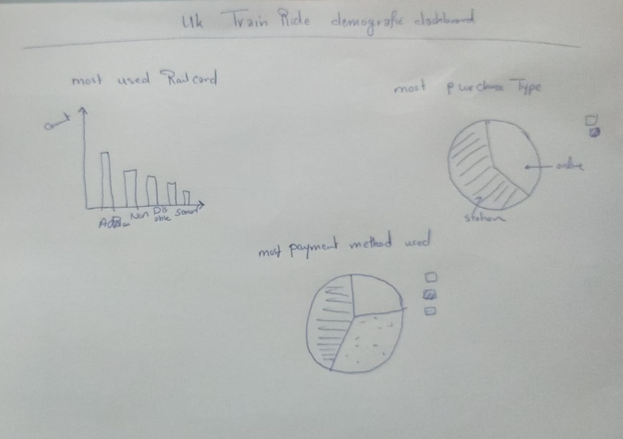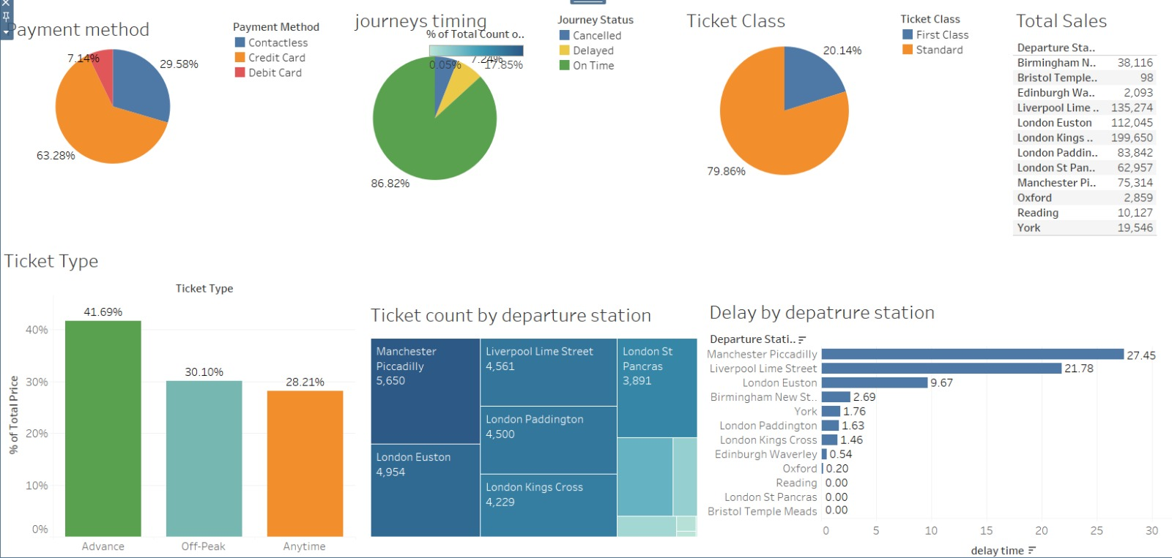

**The Analytical dashboard comes with 4 different tabs each**

**considering a separate field to analyze.**

**Sample of charts**

